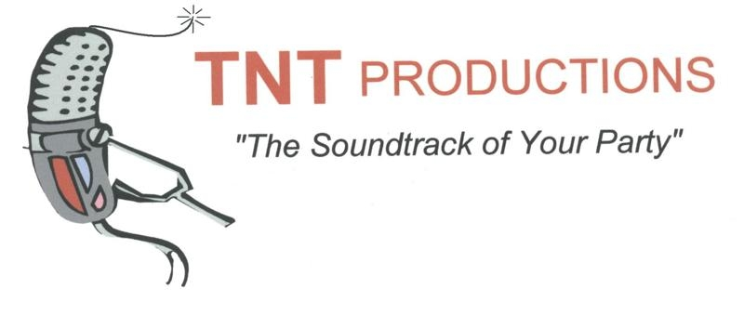
djjazzytymm@att.net
You opinion matters! We are constantly striving for total customer satisfaction. Please take a moment to fill out this survey and email it back to us. We want to hear the good, bad, and ugly!
- How was our overall appearance?__________________________________________________
_____________________________________________________________________________________
_____________________________________________________________________________________
- Describe our selection of music for your event._______________________________________
_____________________________________________________________________________________
_____________________________________________________________________________________
_____________________________________________________________________________________
- How would you describe our coordination of your event? ______________________________
_____________________________________________________________________________________
_____________________________________________________________________________________
_____________________________________________________________________________________
- After the performance, what were your feelings on how the event turned out? _____________
_____________________________________________________________________________________
_____________________________________________________________________________________
_____________________________________________________________________________________
- How may we improve our service?_________________________________________________
_____________________________________________________________________________________
_____________________________________________________________________________________
_____________________________________________________________________________________

